Test Case: tc003_SPX_Dev5_Crear_Requisicion_Spot_Tipo_Cobro_CC_Urgent
Step 1 - Enter username and password and click to button Enter : Credentials Entered
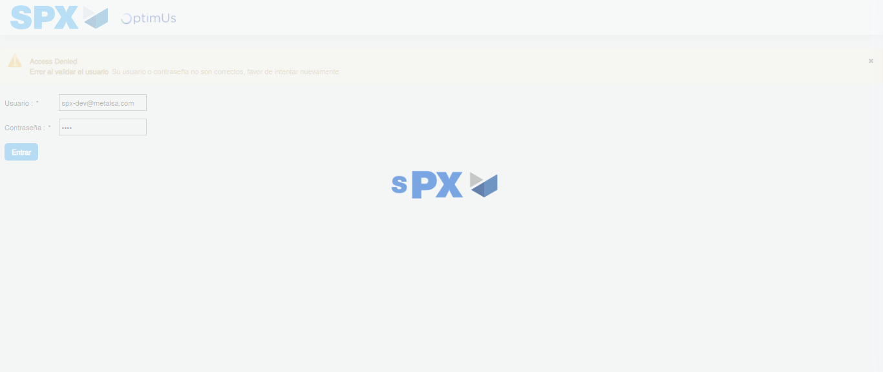Image file-name: QC_Testing-tc003_SPX_Dev5_Crear_Requisicion_Spot_Tipo_Cobro_CC_Urgent-1782238982110

Step 2 - Select to UEN and Access to Spot Buy Requisitions : UEN Correctly selected and Correct access
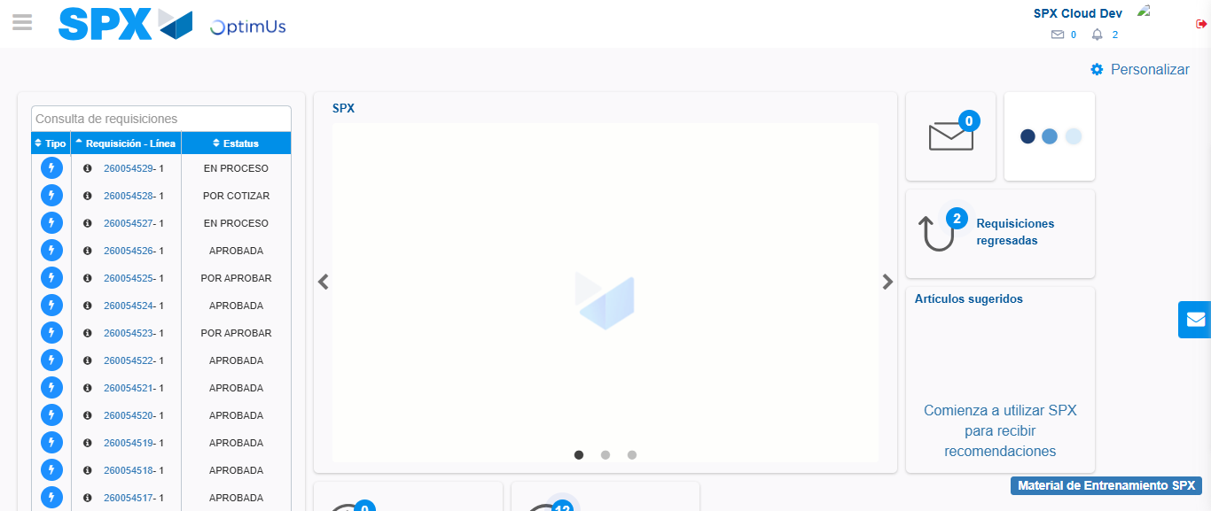Image file-name: QC_Testing-tc003_SPX_Dev5_Crear_Requisicion_Spot_Tipo_Cobro_CC_Urgent-1782239021441

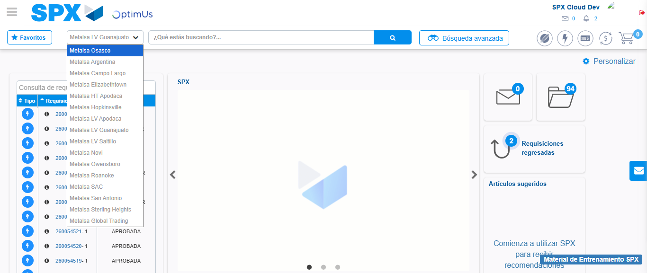Image file-name: QC_Testing-tc003_SPX_Dev5_Crear_Requisicion_Spot_Tipo_Cobro_CC_Urgent-1782239039204

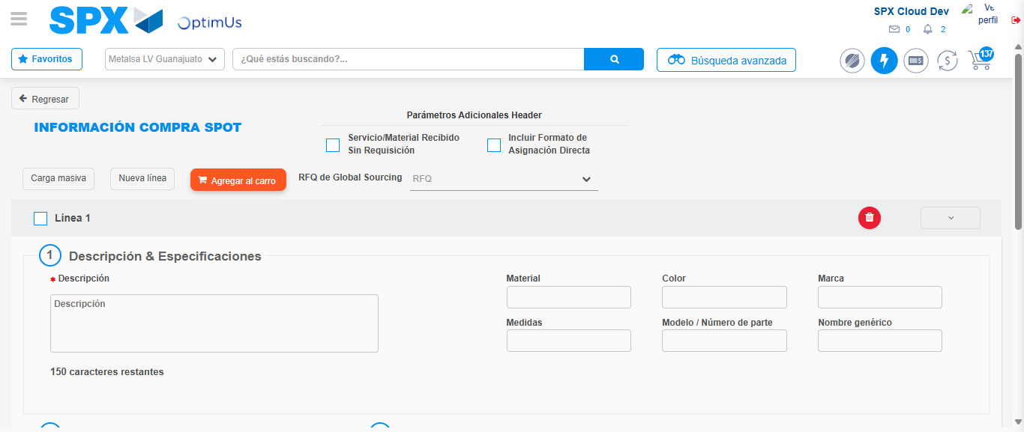Image file-name: QC_Testing-tc003_SPX_Dev5_Crear_Requisicion_Spot_Tipo_Cobro_CC_Urgent-1782239048524

Step 3 - Data Capture Spot Buy Requisition: Data captured correctly
Image file-name: QC_Testing-tc003_SPX_Dev5_Crear_Requisicion_Spot_Tipo_Cobro_CC_Urgent-1782239048772

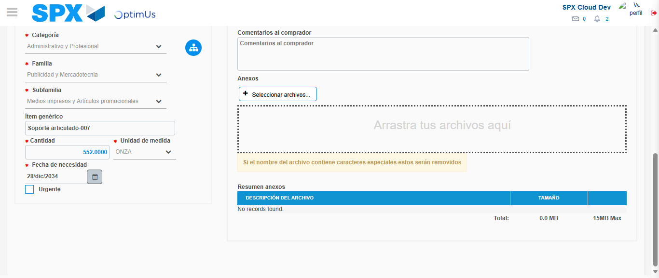Image file-name: QC_Testing-tc003_SPX_Dev5_Crear_Requisicion_Spot_Tipo_Cobro_CC_Urgent-1782239059435

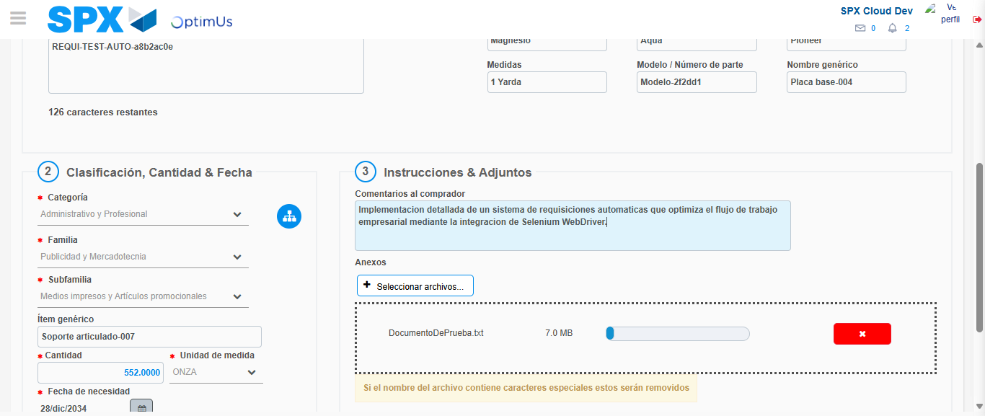Image file-name: QC_Testing-tc003_SPX_Dev5_Crear_Requisicion_Spot_Tipo_Cobro_CC_Urgent-1782239060286

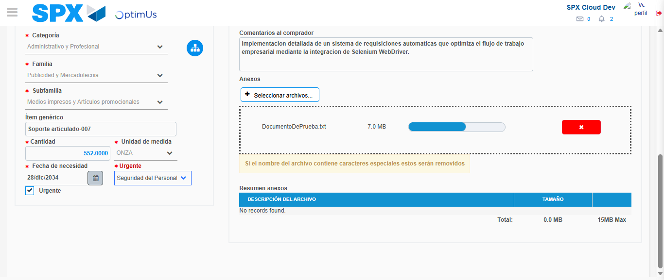Image file-name: QC_Testing-tc003_SPX_Dev5_Crear_Requisicion_Spot_Tipo_Cobro_CC_Urgent-1782239063977

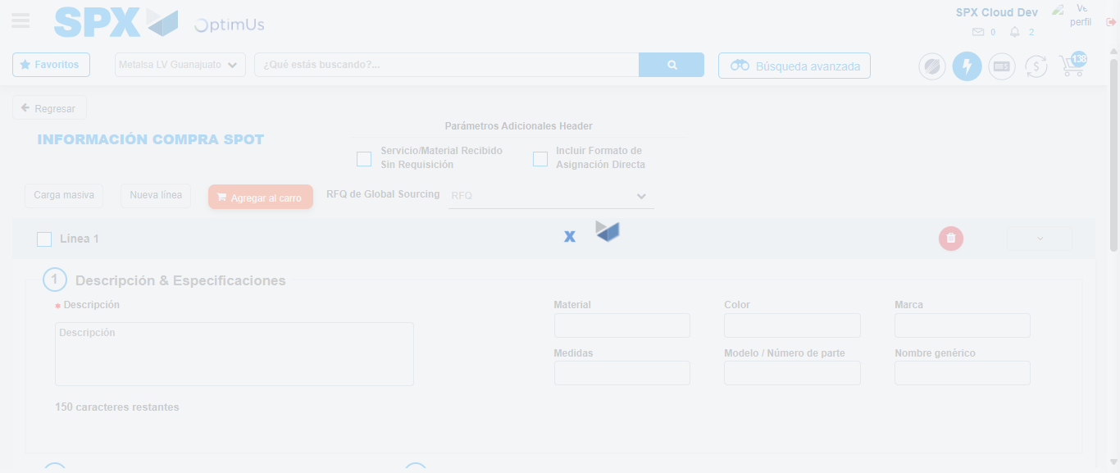Image file-name: QC_Testing-tc003_SPX_Dev5_Crear_Requisicion_Spot_Tipo_Cobro_CC_Urgent-1782239066464

Step 4 - Select to Requisition: Requisition Correctly selected
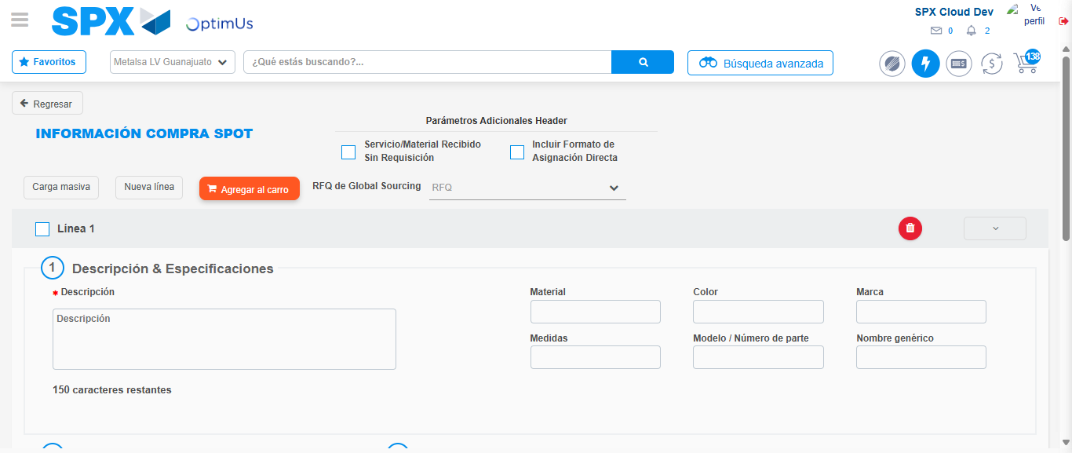Image file-name: QC_Testing-tc003_SPX_Dev5_Crear_Requisicion_Spot_Tipo_Cobro_CC_Urgent-1782239066694

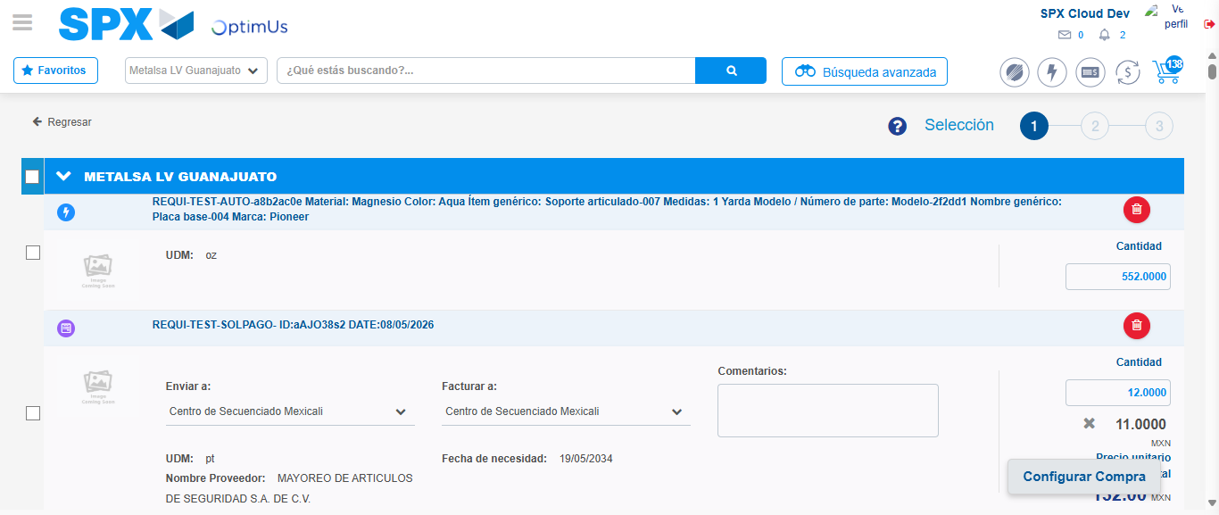Image file-name: QC_Testing-tc003_SPX_Dev5_Crear_Requisicion_Spot_Tipo_Cobro_CC_Urgent-1782239079047

Image file-name: QC_Testing-tc003_SPX_Dev5_Crear_Requisicion_Spot_Tipo_Cobro_CC_Urgent-1782239079375

Image file-name: QC_Testing-tc003_SPX_Dev5_Crear_Requisicion_Spot_Tipo_Cobro_CC_Urgent-1782239079600

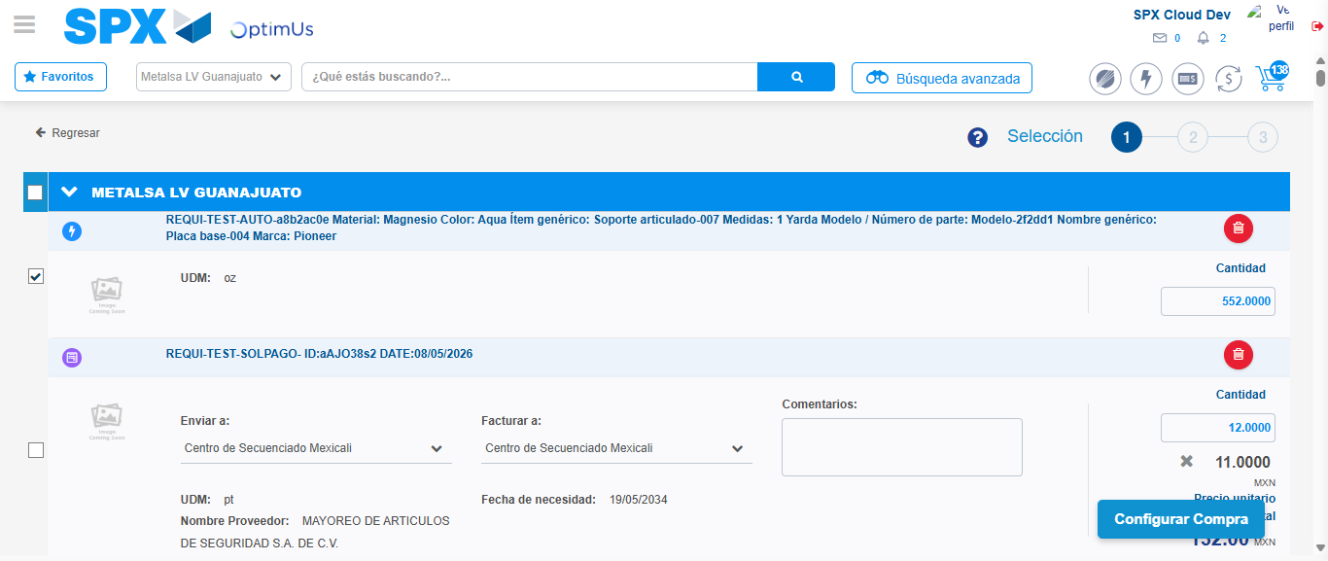Image file-name: QC_Testing-tc003_SPX_Dev5_Crear_Requisicion_Spot_Tipo_Cobro_CC_Urgent-1782239081518

Step 5 - Select Type Account For Requisition: Type Account Correctly selected
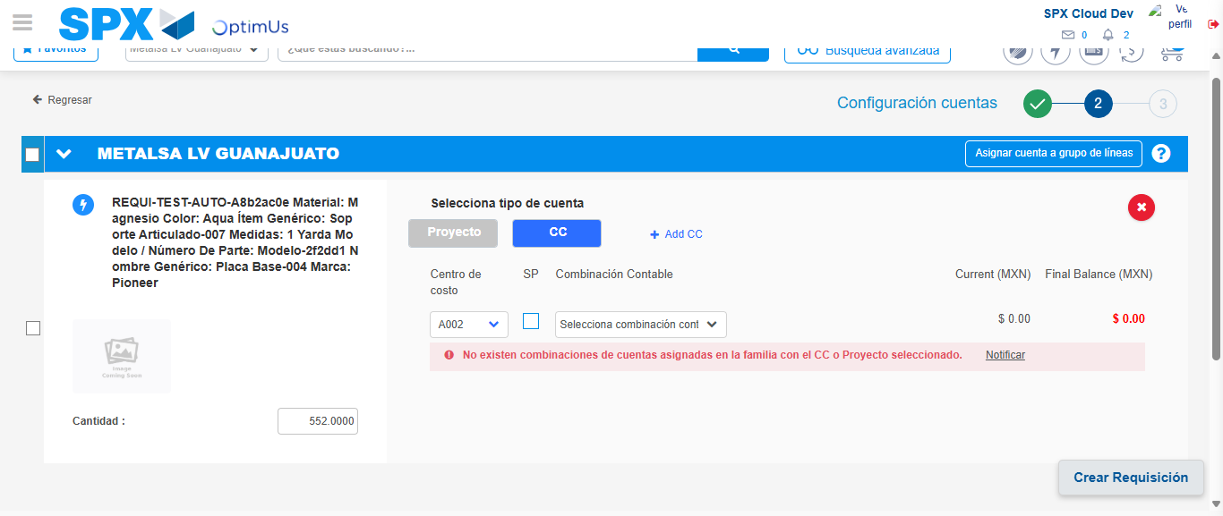Image file-name: QC_Testing-tc003_SPX_Dev5_Crear_Requisicion_Spot_Tipo_Cobro_CC_Urgent-1782239096353

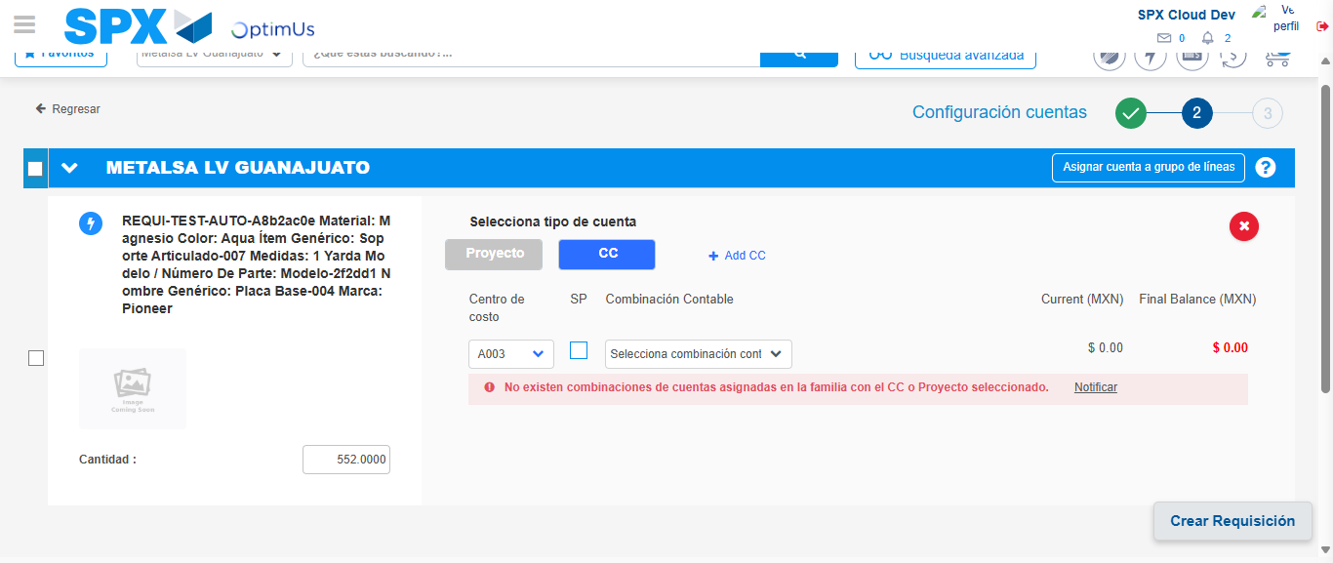Image file-name: QC_Testing-tc003_SPX_Dev5_Crear_Requisicion_Spot_Tipo_Cobro_CC_Urgent-1782239101581

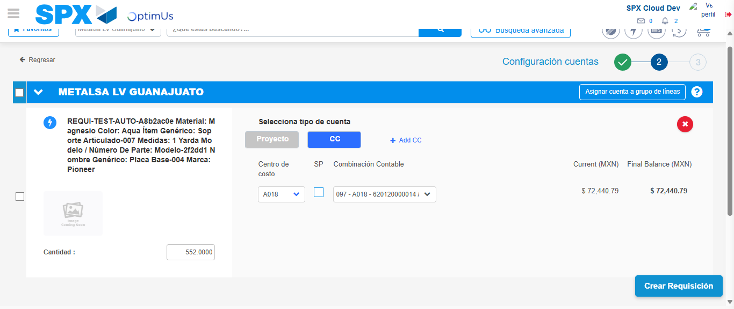Image file-name: QC_Testing-tc003_SPX_Dev5_Crear_Requisicion_Spot_Tipo_Cobro_CC_Urgent-1782239106880

Image file-name: QC_Testing-tc003_SPX_Dev5_Crear_Requisicion_Spot_Tipo_Cobro_CC_Urgent-1782239107057

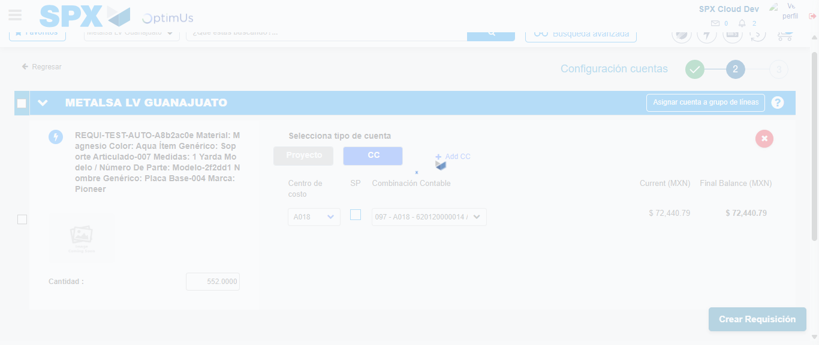Image file-name: QC_Testing-tc003_SPX_Dev5_Crear_Requisicion_Spot_Tipo_Cobro_CC_Urgent-1782239107501

Step 6 - Accept to Requisition: Requisition Accepted
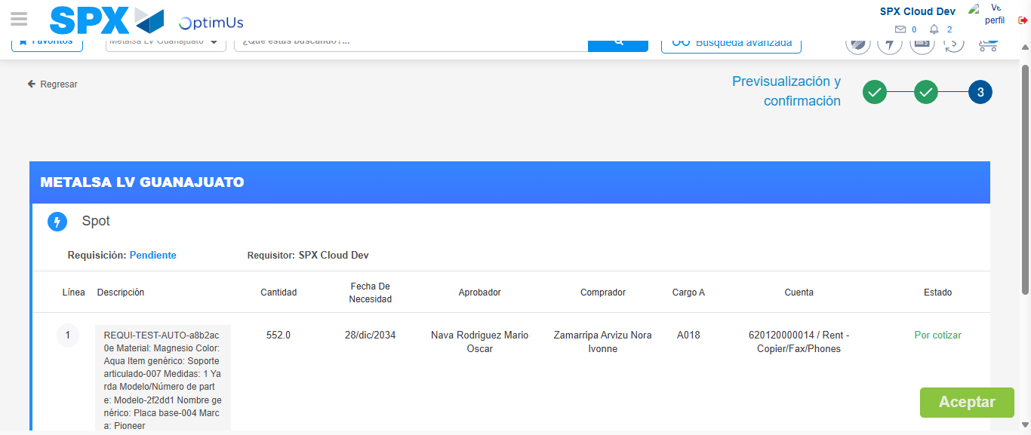Image file-name: QC_Testing-tc003_SPX_Dev5_Crear_Requisicion_Spot_Tipo_Cobro_CC_Urgent-1782239108344

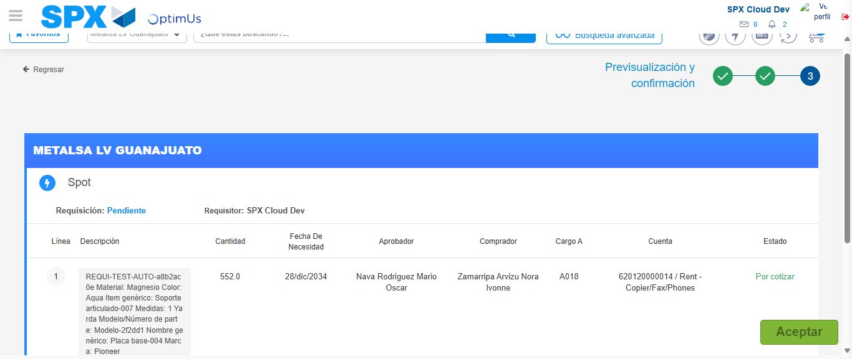Image file-name: QC_Testing-tc003_SPX_Dev5_Crear_Requisicion_Spot_Tipo_Cobro_CC_Urgent-1782239108616

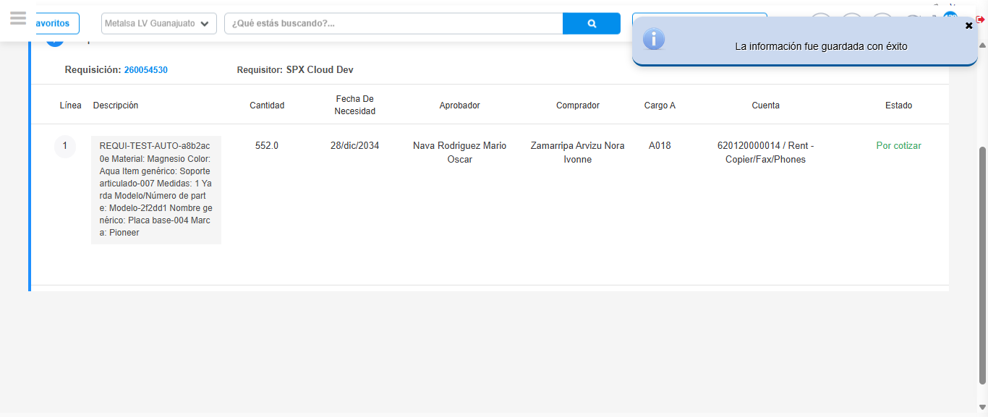Image file-name: QC_Testing-tc003_SPX_Dev5_Crear_Requisicion_Spot_Tipo_Cobro_CC_Urgent-1782239112091

Step 7 - Return to Main Page SPX : Return to Main Page SPX
Image file-name: QC_Testing-tc003_SPX_Dev5_Crear_Requisicion_Spot_Tipo_Cobro_CC_Urgent-1782239021441

Image file-name: QC_Testing-tc003_SPX_Dev5_Crear_Requisicion_Spot_Tipo_Cobro_CC_Urgent-1782239039204

Image file-name: QC_Testing-tc003_SPX_Dev5_Crear_Requisicion_Spot_Tipo_Cobro_CC_Urgent-1782239048524

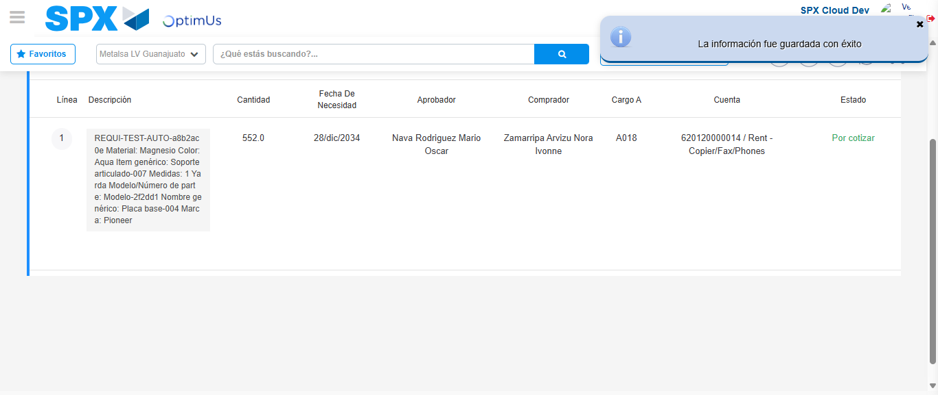Image file-name: QC_Testing-tc003_SPX_Dev5_Crear_Requisicion_Spot_Tipo_Cobro_CC_Urgent-1782239114308

Image file-name: QC_Testing-tc003_SPX_Dev5_Crear_Requisicion_Spot_Tipo_Cobro_CC_Urgent-1782239114459

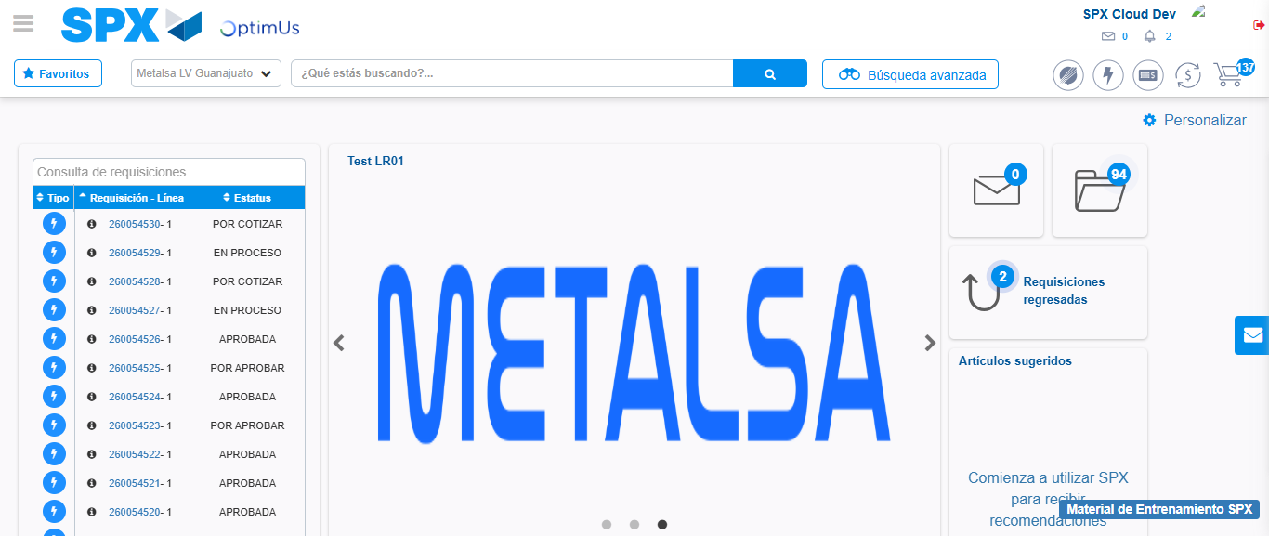Image file-name: QC_Testing-tc003_SPX_Dev5_Crear_Requisicion_Spot_Tipo_Cobro_CC_Urgent-1782239135449

Step 8 - Log Out : Log Out SPX
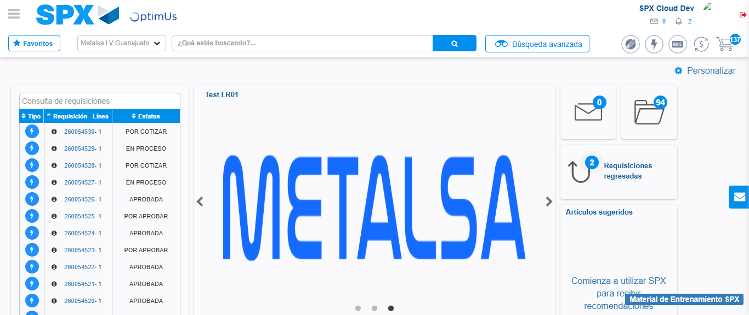Image file-name: QC_Testing-tc003_SPX_Dev5_Crear_Requisicion_Spot_Tipo_Cobro_CC_Urgent-1782239135697

